You will need this when you log onto Google Classroom for your child.

1. 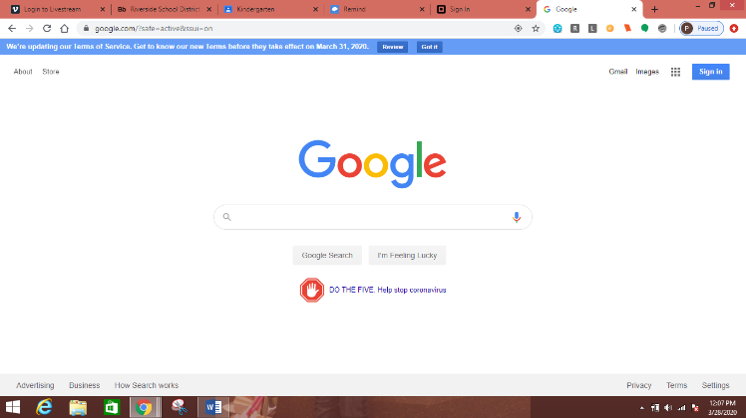Go to google.com and click on the “Sign In” at the top right corner.

1. When asked for email you will enter your child's school username (the one they use to login to the computers). This is the first 3 letters of their last name, the first 3 letters of their first name, and their graduation year. You will add @riversidesd.com to the end and then click "Next"

Example: a kindergarten student named John Smith would be: [smijoh32@riversidesd.com](mailto:smijoh32@riversidesd.com)

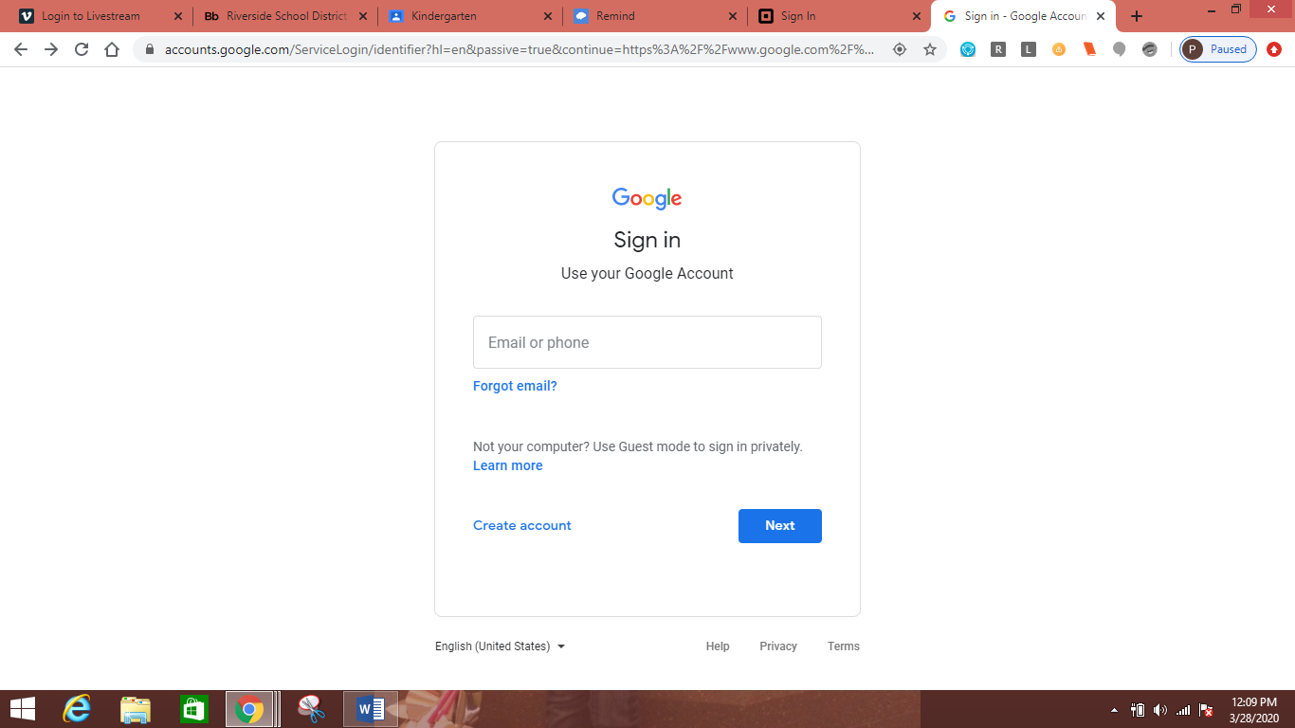

After you put the email in the box, click “Next”

3. Enter password. For ALL students the password is Capital R, lowercase s, lowercase d, and then the child's student ID. Most students in grades 2 - 6 already know this. If your child does not it can be found on their ID badges under their name. If they do not have it, please email me and I will get it for your child.

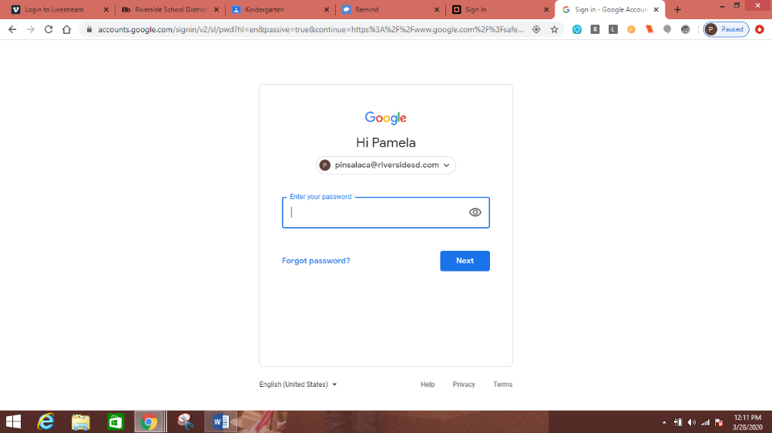Example: Rsd123456

After entering password, click “Next”.

1. 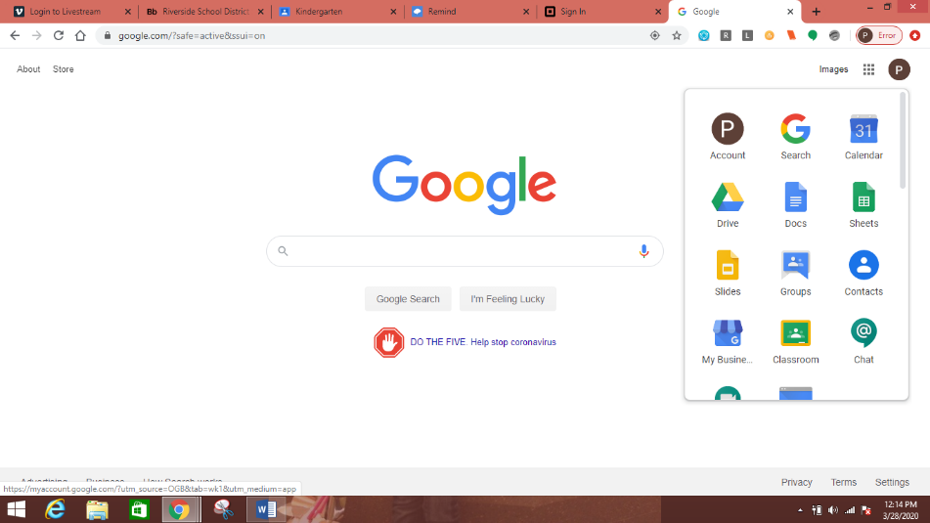Click on the 9 squares in the top right corner then click Classroom.
2. Click on the + on the top right and click “Join Class”

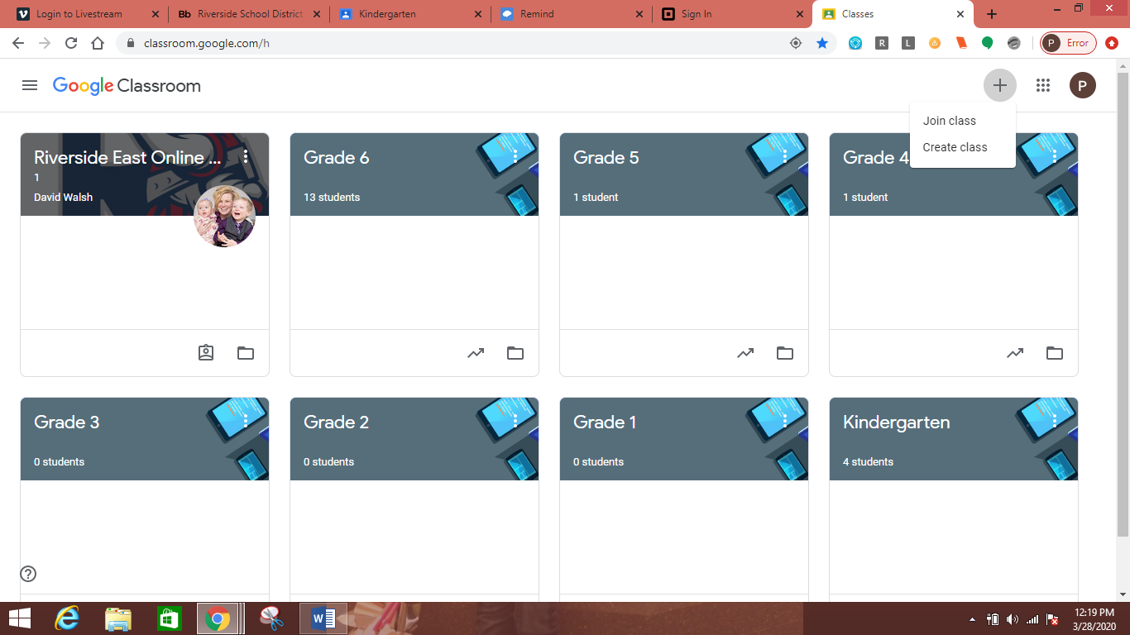

1. Enter the Class code (listed on Mrs. Insalaca’s teacher page) for your child’s grade level and click Join.

--If you have more than one child, each child will need to join the class for their grade level.

If you have any questions please email me at [pinsalaca@riversidesd.com](mailto:pinsalaca@riversidesd.com) or join the Remind for your child’s grade level.